 

INSTITUTE FOR ADVANCED COMPUTING AND SOFTWARE DEVELOPMENT AKURDI, PUNE

Documentation On

**“ECO-B POINT”**

E-DAC AUG 2020

*Submitted By:*

**Group No: 66**

**Rohit Sanjay Patil-2123**

**Sayali Vikas Bhavsar-2164**

**Prashant Karhale Mr. Milind Arjun**

**Centre Coordinator Project Guide**

# Table of Contents

1. Introduction 1

Document Purpose 2

Problem Statement 2

Product Scope 2

Aim & Objectives 2

1. Overall Description 3

Product Perspective 3

Benefits of Society Management System 3

User and Characteristics 3

Operating Environment 3

Design and Implementation Constraints 3

1. Requirements Specification 4

External Interface Requirements 4

3.3 Non-Functional Requirements 12

1. System Diagram 11

Activity Diagram 11

Data Flow Diagram 13

Class Diagram 15

Use Case Diagram 16

ER Diagram 16

1. Table Structure 17

Flat owners 17

Notices 17

Complaints 17

Visitors 18

Bill 18

Workers 18

1. Conclusion 19

Future Scope 19

1. References 20

**List of Figures**

Figure 1 Admin Activity Diagram 12

Figure 2 User Activity Diagram 12

Figure 3 Level 0 Data Flow Diagram 13

Figure 4 Level 1 Data Flow Diagram 13

Figure 5 Level 2 Data Flow Diagram for Admin 13

Figure 6 Level 2 Data Flow Diagram for User 13

Figure 7 Class Diagram 14

Figure 8 Sequence Diagram 15

Figure 9 Use Case Diagram 15

Figure 10 ER Diagram 16

# Introduction

Our topic is “ECO-B Point”. So we are developing application for managing electric bicycles for people where they have to travel but driving a car or other vehicle becomes much more expensive and walking becomes monotonous. So we came up with an Idea to have bicycle stations near buildings where people generally travel when they want to take a ride. They will just book a bicycle and take it for a ride. They can select between available locations in that area and use bicycles for commute purposes. In case if there is no bicycle available nearby the station a user can call a bicycle from another station and because of electric it can travel from that point to the user and he can use it for his traveling purpose. Also riding a bicycle is also considered as an exercise so on weekends or evening time a user can take it out for a casual ride accordingly his data for that particular ride is calculated and saved. We can implement this in residential complexes, offices, parks, etc.

## Document Purpose

This Eco-B Point System is developed to provide the following services:

Book Ride:

User selects the starting and destination location after selecting bicycle is allotted to the user. After ending ride release bicycle from user and the bicycle with another location.

Report Broken Bicycle:

If there’s any broken bicycle allotted to a user then there must be a provision to user to report it. Admin can inspect bicycles and make them available to serve users after repairing is done.

## Problem Statement

Existing system is developed for only cars; we have developed for the bicycles. This system is developed for user convenience, user will easily book a bicycle ride by using this application. We have this application is basically design for colleges.

## Product Scope

This project is design for Book the bicycle ride. The area covers include:

* College Campus: This application is used in college campus
* Spring Boot Technology used for the development of the application.
* Student, all college staffs will be able to use the system effectively.
* Web-platform means that the system will be available for access 24/7 except when there is a temporary server issue which is expected to be minimal.

## Aims & Objectives

Specific goals are: -

* To produce a web-based system that allows the user to book bicycle rides and provide functionalities to its role.
* To ease admin by providing different functionalities to it.

# Overall Description

## Product Perspective:

Existing system function:

In this bicycle book system we are going to introduce online booking of bicycle will be available. So the burden of the user will be reducing. Our aim is to design and create data management system for bicycle book system. In this system user book a ride and admin will accept the bicycle request then assign the available bicycle and then confirm the ride. Also show the all bicycles request in admin.

**PROPOSED SYSTEM**

Product functionality:

Eco-B Point System provides the features for admin, user. It includes several functionalities describes as below:

*Book Ride:*

This Functionality is provide for user will select the starting and destination location then book the ride admin will accept the request then available bicycle is allot and after end ride release the bicycle.

*Report Broken Bicycle:*

If there’s any broken bicycle allotted to a user then there must be a provision to user to report it. Other bicycle is allotted to user.

*Accept the ride request:*

Admin can accept the ride request then user can start his ride after completing ride release the bicycle.

## Benefits of Eco-B Point Application:

* This online Eco-B Point application is fully functional and flexible.
* It is very easy to use.
* This online society management system helps in back office administration by streamlining and standardizing the procedures.
* It saves a lot of time.
* Eco-friendly: This Eco-B Point system is online
* The application acts as an college that is open 24/7.
* It increases the efficiency of the management at offering quality services to the users.
* It provides custom features development and support with the application.

## Users and Characteristics:

## Users:

## Admin

## Admin can login to the system.

## View the list of all request.

## Accept/reject the request.

## Add or remove the cycle.

## User

## User can register.

## User can login to the system.

## Book the ride.

## Report Broken bicycle

**Functional Requirements :**

* **Register**

1. New users can register through the register option.
2. Required details are entered through a form(after verification) and saved in the database.(Users Table)

* **Login**

1. Previous users can login through mobile number and password. After verifying from DB(Users table).
2. If a mobile number is not found in DataBase then send user to the front page.

* **Book** a ride(After successful login)

1. Give starting point
2. Enter destination
3. Allot a bicycle(From DB of all bicycles filter which are available at that particular point/stop)
4. Release bicycle from user and set that bicycle with another point/stop.

* Get **list** of available **point/stop** to travel.

1. While a user chooses to go for a ride, his boarding point is chosen from his location and closest point/stop to him.
2. Now for destination except his standing point/stop other locations are shown as destination to him.
3. User can choose any of destinations and start his ride with a system allocated bicycle.

* **Track** and **predict** time for travel.

1. Users must get estimated time for his ride.
2. We can make this possible with Google maps API.

* Report **broken** bicycle.

1. If there’s any broken bicycle allotted to a user then there must be a provision to user to report it.
2. If user reports any bicycle then that bicycle is temporarily removed from bicycles database and shifted to the maintenance database(Maintenance database/table).
3. Admin can inspect bicycles and make them available to serve users after repairing is done.

* Get a bicycle available if **not available** to the **nearby station**.

1. If user wants a bicycle for ride but there’s no bicycle available at the closest point/stop then it’s responsibility of system to prompt user if he wants to continue his ride.
2. If user wants to continue his ride then system should automatically select a bicycle from next closest point/stop. And deliver it to that user’s point/stop.(bicycle is shifted from one point to another point)
3. After this all ride starts for user

* Manage bicycles as per **rush hours**.(OPTIONAL)

1. Find on which times at which point/stop requirement of bicycle increases.
2. Now find nearest couple of points/stops to that point and send bicycles automatically to that point/stop where rush is expected.

* Save **user data**(getting reports, etc) - specifically for casual rides.(OPTIONAL)

1. Save user data for any/every ride
2. Data like distance travelled, total ride time.

* Save **previous** rides.(OPTIONAL)

1. Save previous rides (recent 2/5/10) for every user.

* Receive **personalised ride recommendations** according to users' frequent rides.(OPTIONAL)

1. On the basis of previous rides, give ride recommendations to the user.
2. Like if a particular user takes ride at 8:00AM everyday, then ask him to book ride on 7:50AM.

## Operating Environment:

Server Side:

**Processor:** Intel® Xeon® processor 3500 series

**HDD:** Minimum 500GB Disk Space

**RAM:** Minimum 2GB **OS:** Windows 10 **Database:** MySQL

Client Side (minimum requirement):

**Processor:** Intel Dual Core

**HDD:** Minimum 80GB Disk Space

**RAM:** Minimum 1GB

**OS:** Windows 10

## Design and Implementation Constraints:

* The application will use Spring Boot, HTML, CSS, thymeleaf as main web technologies.
* HTTP protocols are used as communication protocols. FTP is used to upload the web application in live domain and the client can access it via HTTP protocol.
* Several types of validations make this web application a secured one and SQL Injections can also be prevented.
* Since Eco-B Point Application is a web-based application, internet connection must be established.
* The Eco-B Point Application will be used on PCs and will function via internet or intranet in any web browser.

# 

# Specific Requirement

## External Interface Requirements:

User Interfaces:

* + All the users will see the same page when they enter in this website. This page asks the users a mobilenumber and a password.
  + After being authenticated by correct mobilenumber and password, user will be redirect to their corresponding profile where they can do various activities.
  + The user interface will be simple and consistence, using terminology commonly understood by intended users of the system. The system will have simple interface, consistence with standard interface, to eliminate need for user training of infrequent users.

Hardware Interfaces:

* + No extra hardware interfaces are needed.
  + The system will use the standard hardware and data communication resources.
  + This includes, but not limited to, general network connection at the server/hosting site, network server and network management tools.

Application Interfaces:

**OS:** Windows 10

**Web Browser:**

The system is a web-based application; clients need a modern web browser such as Mozilla Firebox, Internet Explorer, Opera, and Chrome. The computer must have an Internet connection in order to be able to access the system.

Communications Interfaces:

* + This system uses communication resources which includes but not limited to, HTTP protocol for communication with the web browser and web server and TCP/IP network protocol with HTTP protocol.
  + This application will communicate with the database that holds all the booking information. Users can contact with server side through HTTP protocol by means of a function that is called HTTP Service. This function allows the application to use the data retrieved by server to fulfill the request fired by the user.

# System Design

## Activity Diagram

## 

**Figure 1: Admin Activity Diagram**

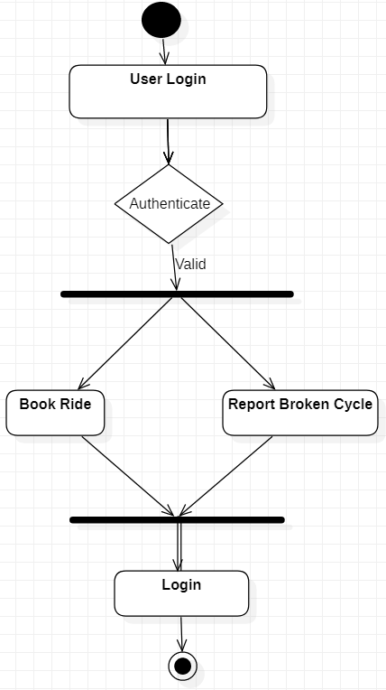

**Figure 2: User Activity Diagram**

## Data Flow Diagram

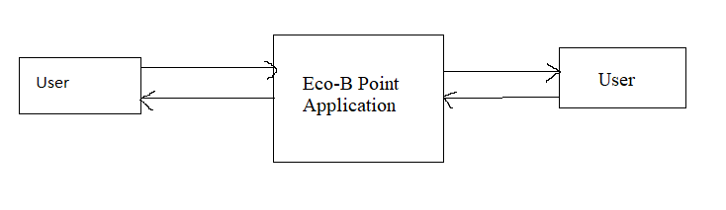

**Figure 3: Level 0 Data Flow Diagram**

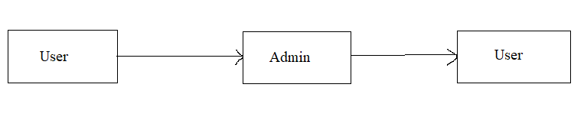

**Figure 4: Level 1 Data Flow Diagram**

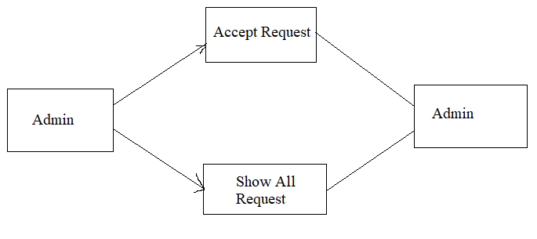

**Figure 5: Level 2 Data Flow Diagram for Admin**

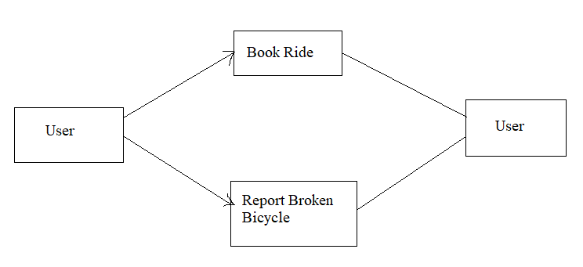

**Figure 6: Level 2 Data Flow Diagram for User**

## 

## Class Diagram

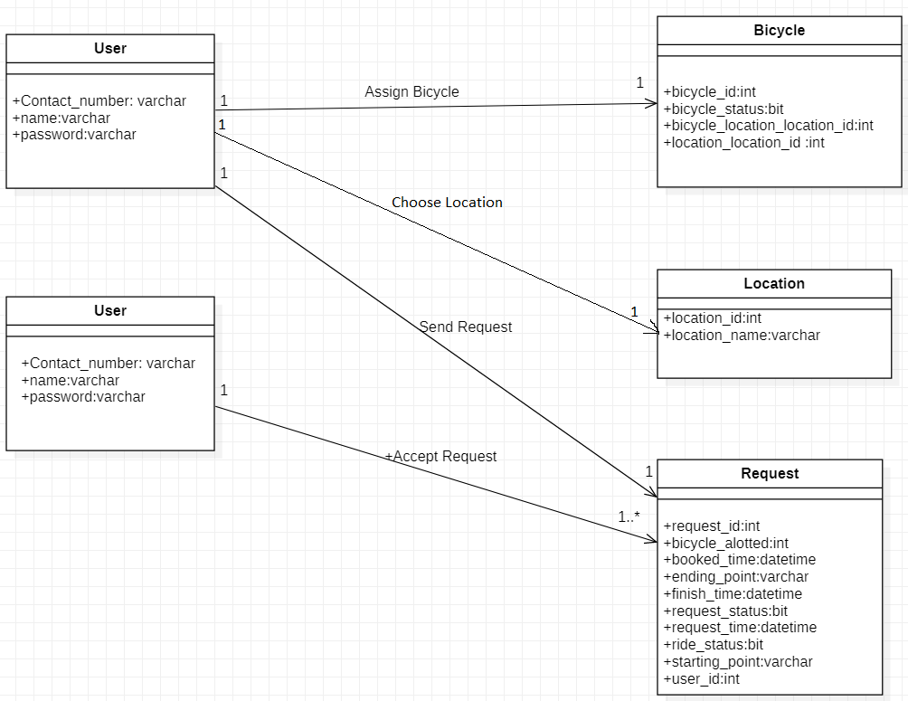

**Figure 7: Class Diagram**

**Sequence Diagram**

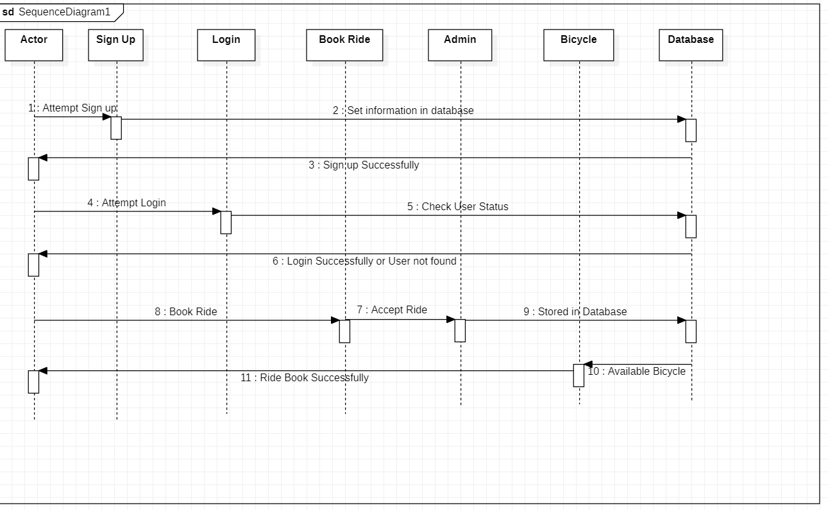

**Figure 8: Sequence Diagram**

## Use Case Diagram

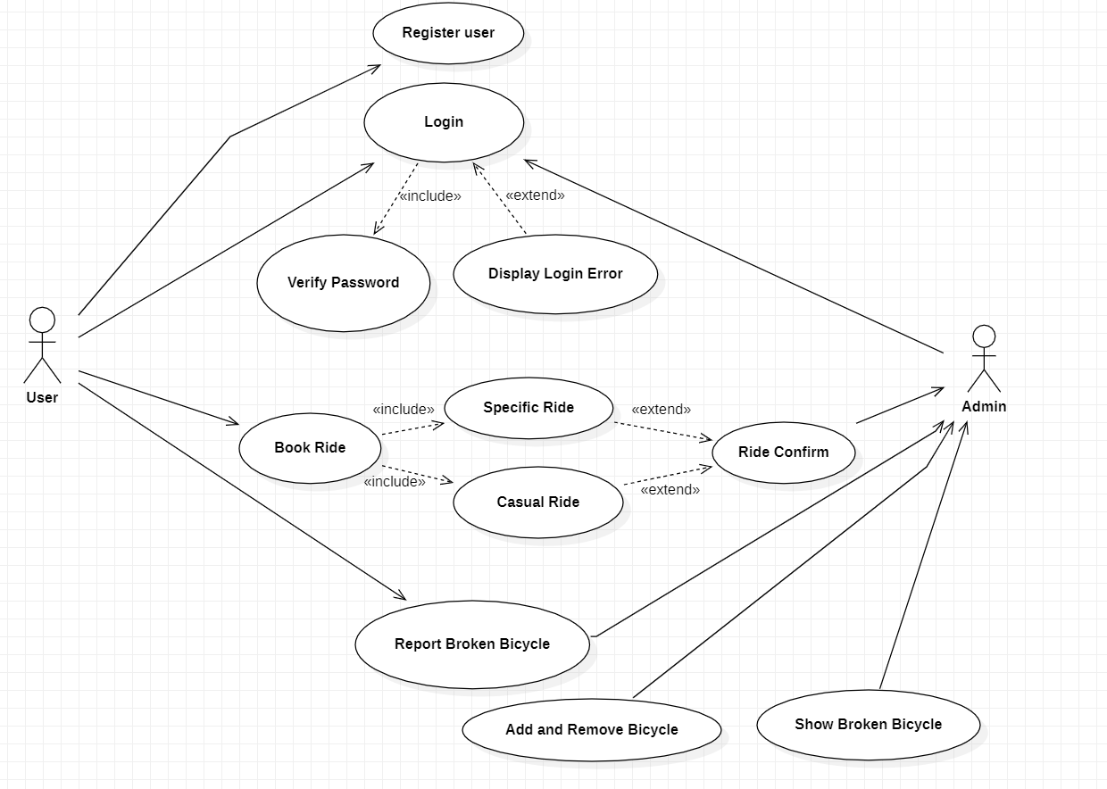

**Figure 9: Use Case Diagram**

## ER Diagram

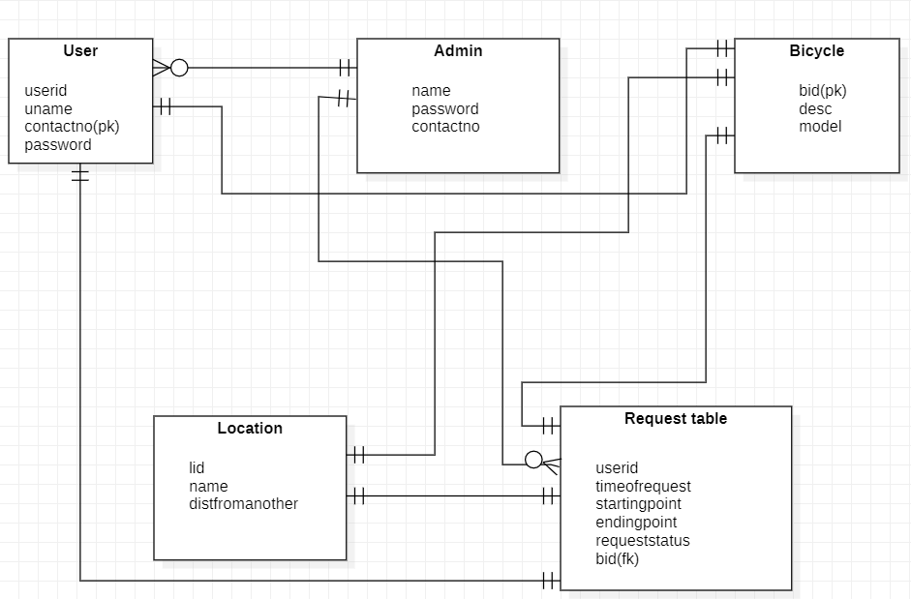

**Figure 10: ER Diagram**

**Screenshots:**

1. Home Page: this is welcome page for ECO-B application. Here you can find links for all of our services.

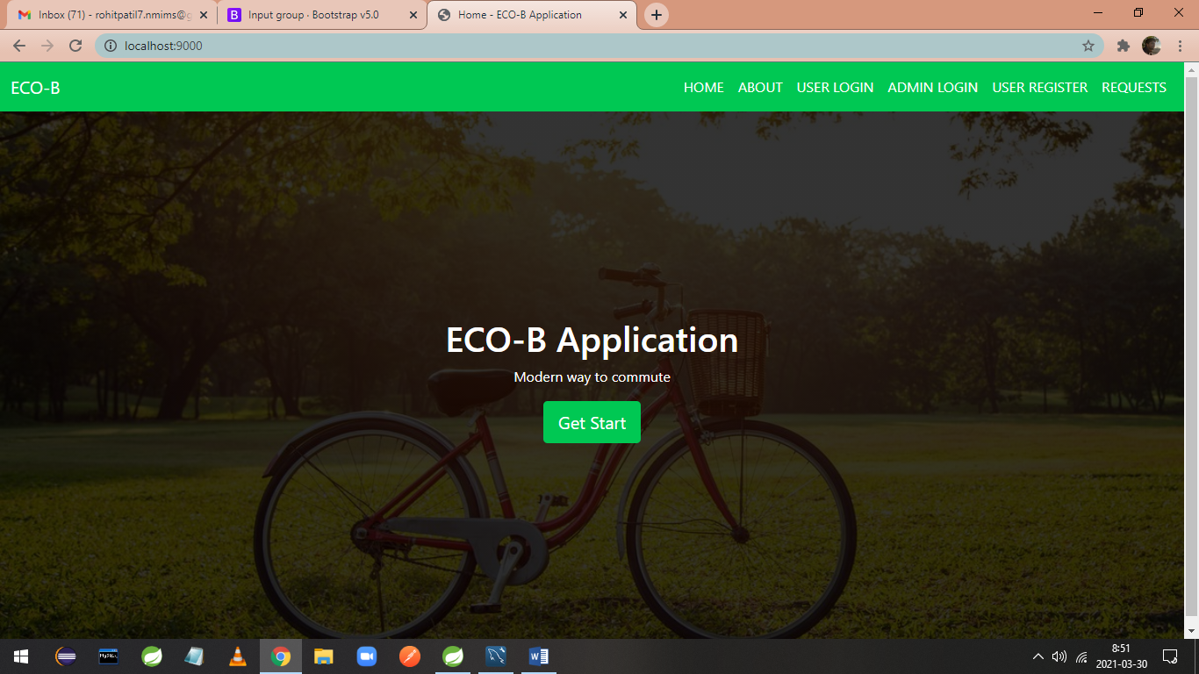

1. Request Dashboard: Here we can see all received requests and completed requests from users.

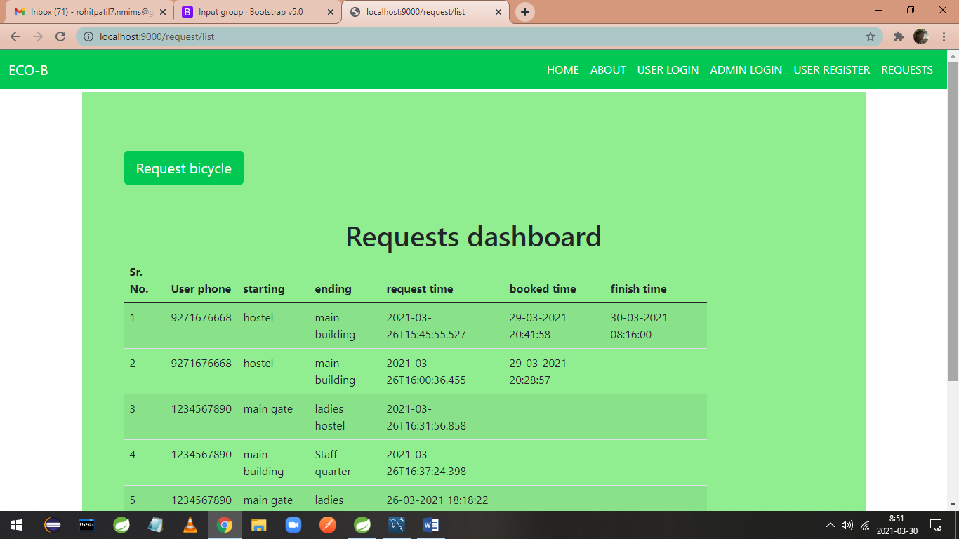

1. Request form: After clicking on request bicycle following menu shows up.

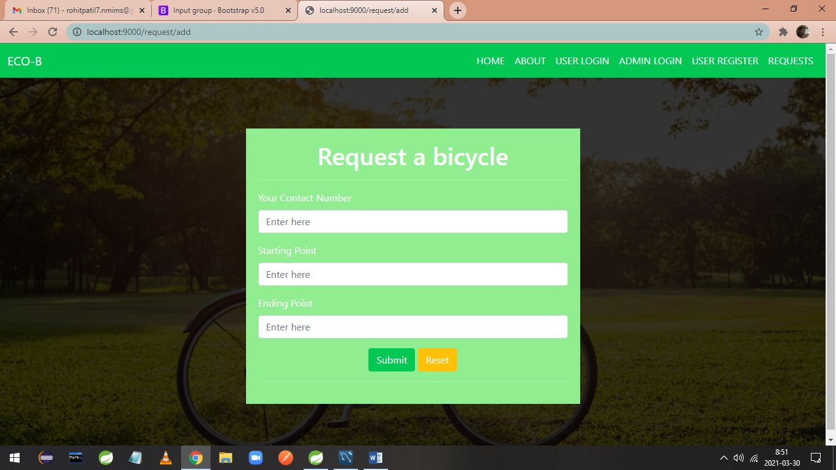

1. You can fill your details as given below.

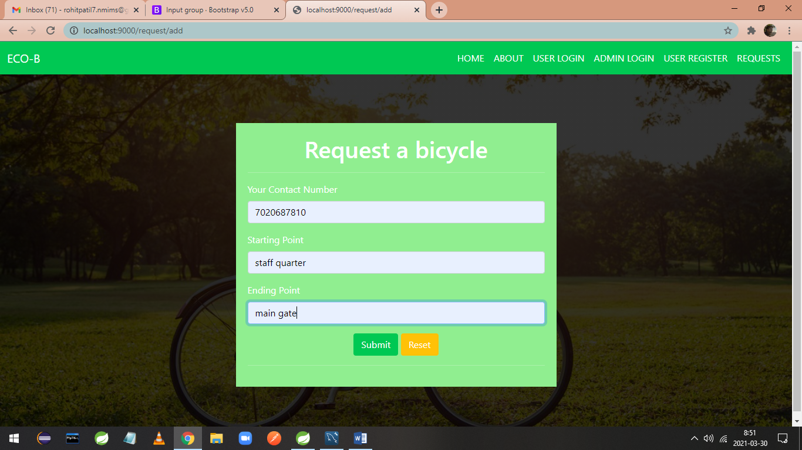

1. User request gets added in database as per details provided. Also request time is updated.

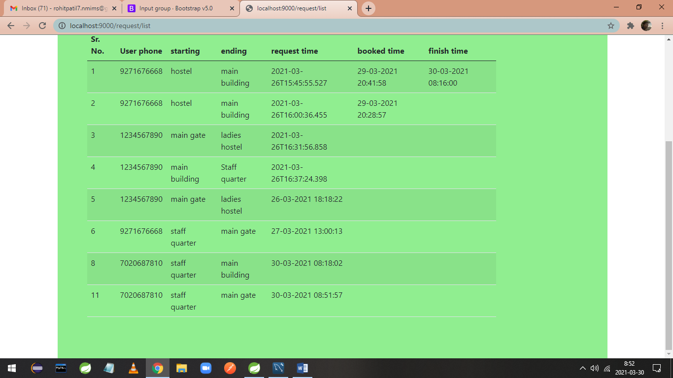

1. Admin login: now admin can login with his credentials, with help of admin login option.

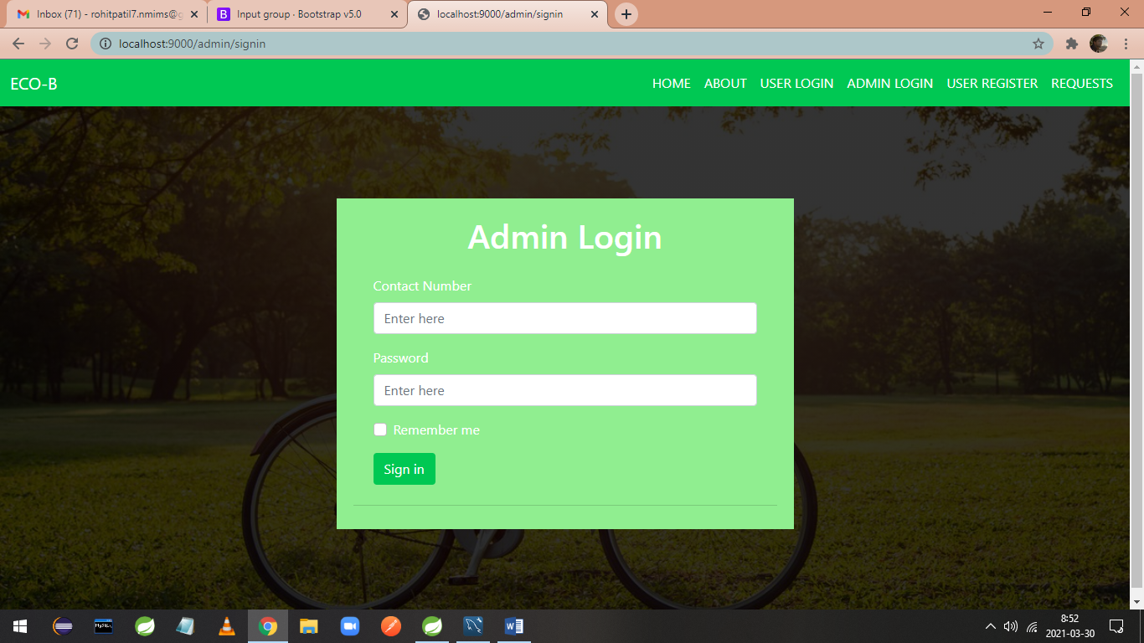

1. Admin dashboard: now admin is directed to admin dashboard. Where he has various options to see requests and logout.

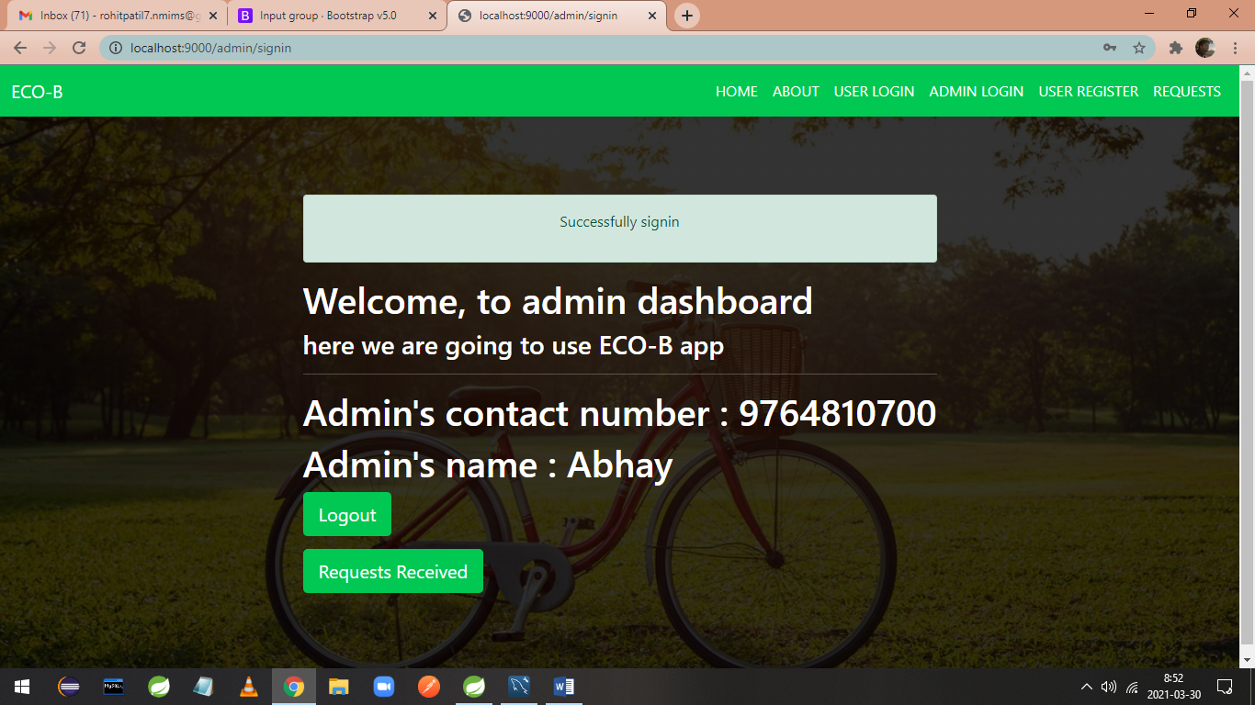

1. After clicking on requests received admin directed to request’s dashboard.

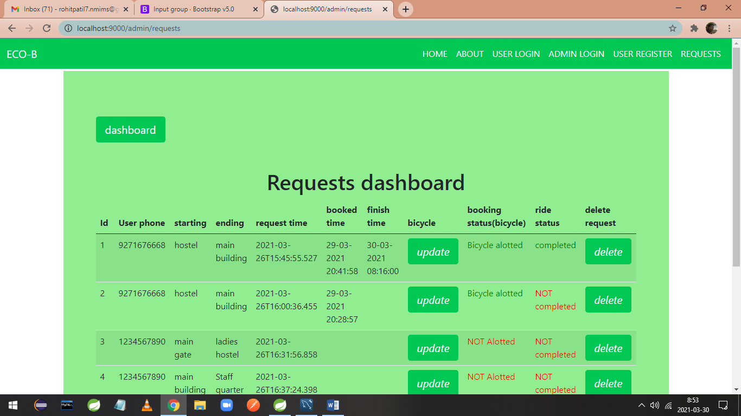

1. Here admin can click on update option to assign bicycle to user so user can take bicycle and start his ride.

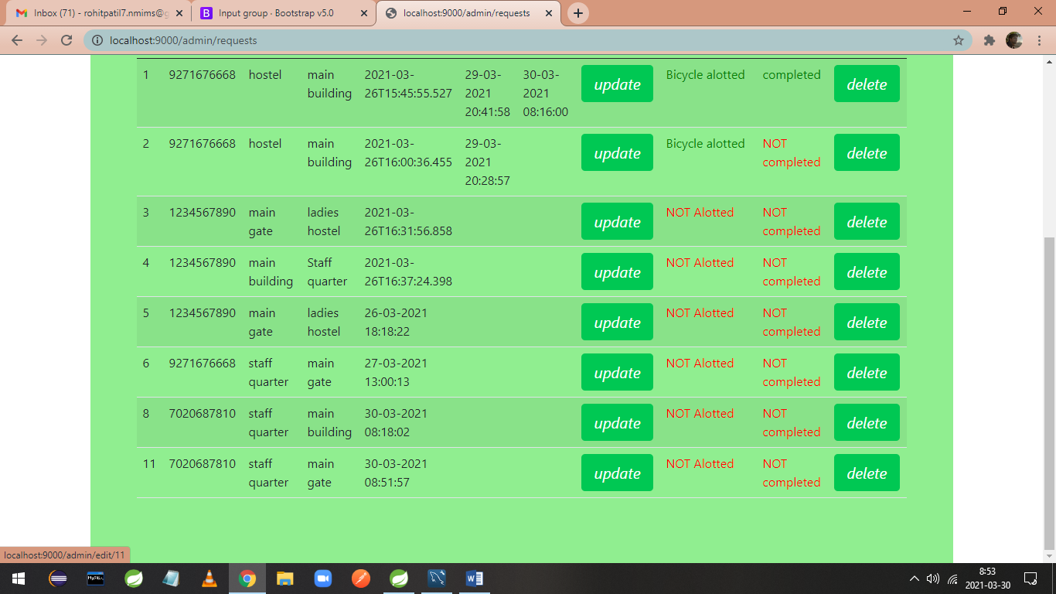

1. Assign form: here admin can edit bicycle for specific request.

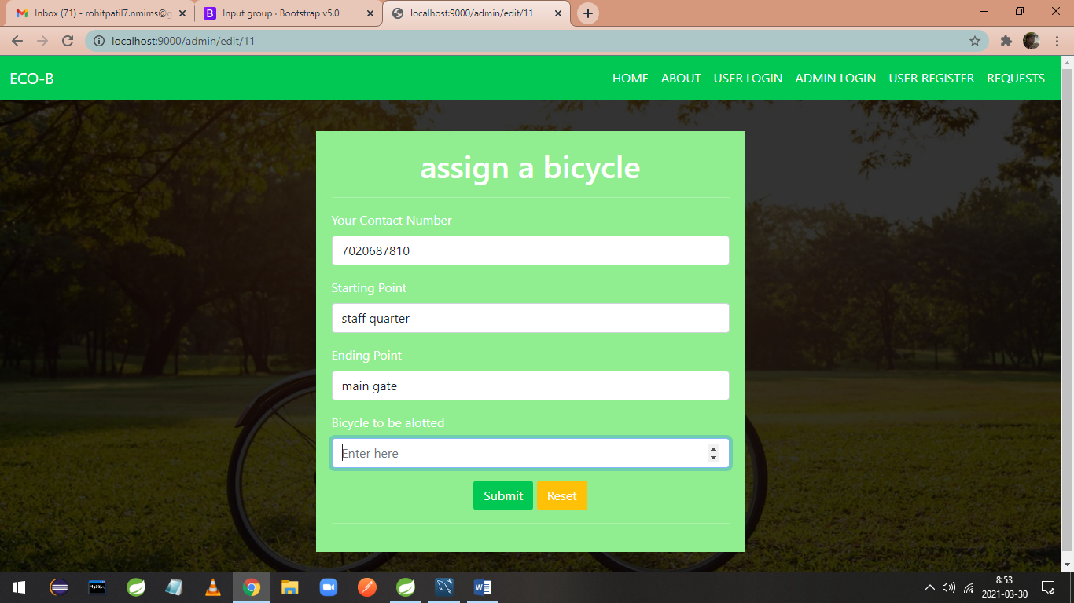

1. After assigning bicycle admin can submit form.

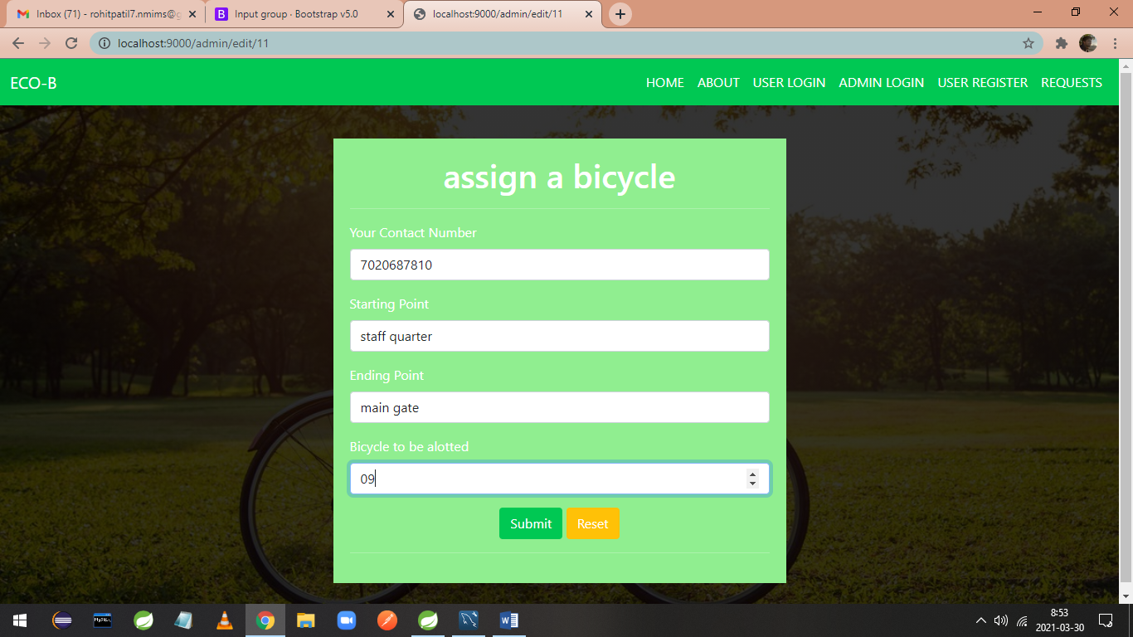

1. After assigning bicycle booked time updated for specific request.

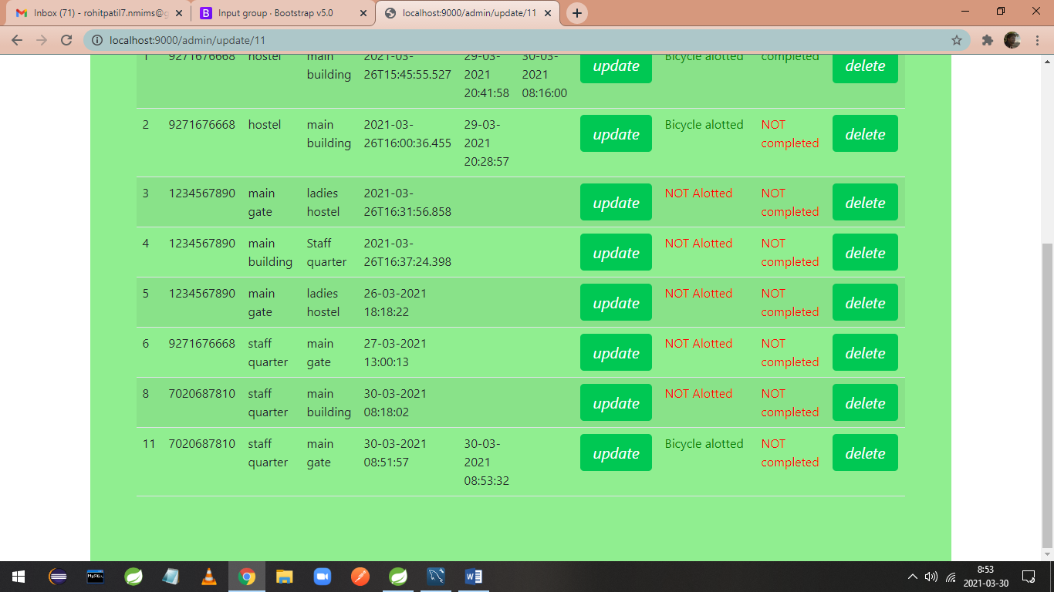

1. That’s all about admin role, now he can logout from admin dashboard. After 5 seconds you are automatically directed to homepage.

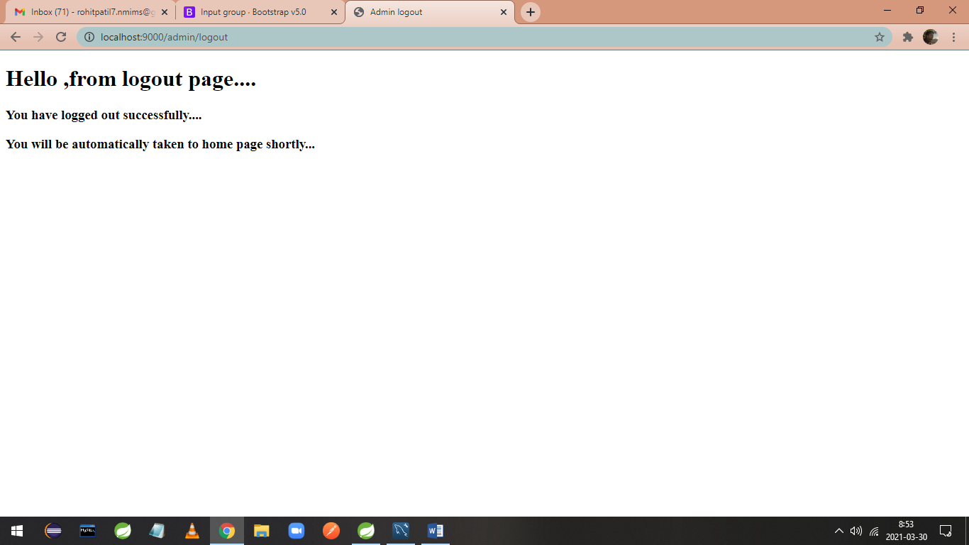

1. User can login with user login option.

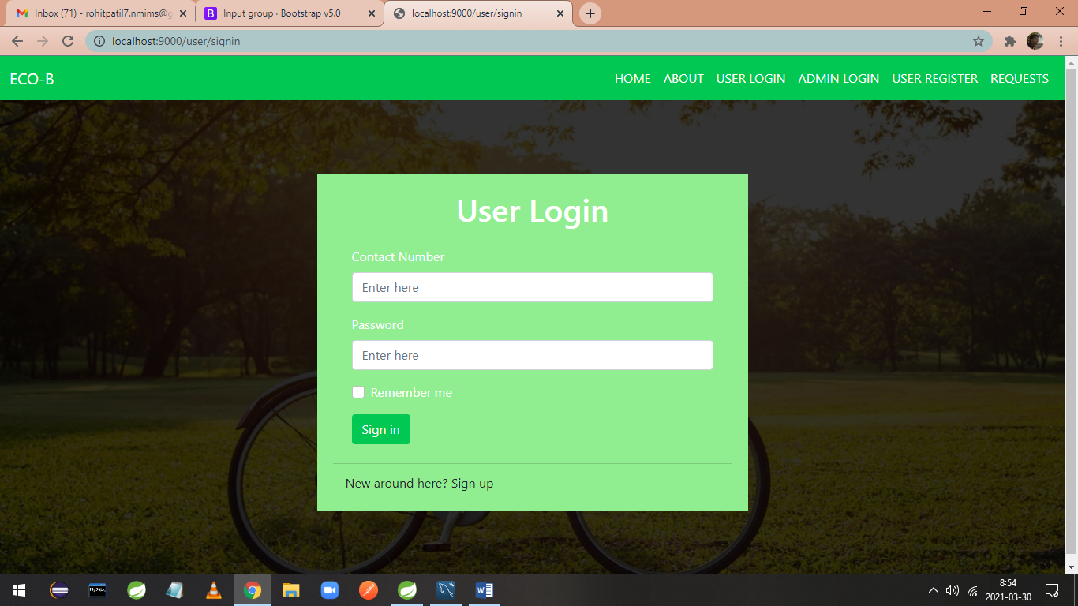

1. User can login with user credentials

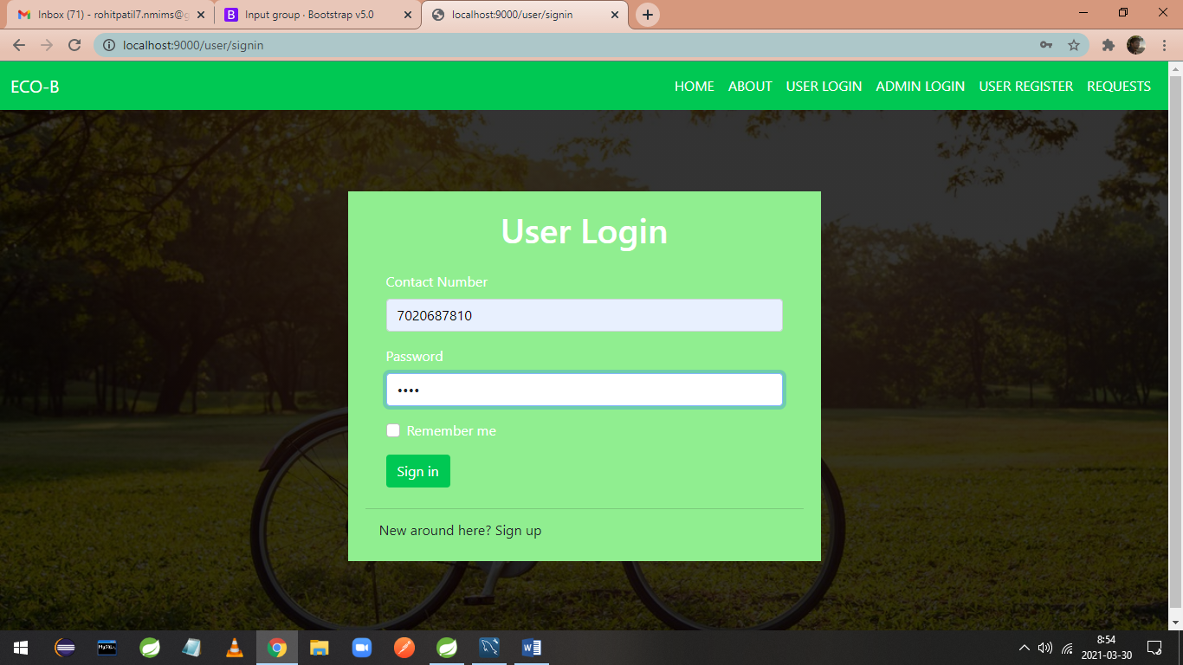

1. On success user is directed to his dashboard.

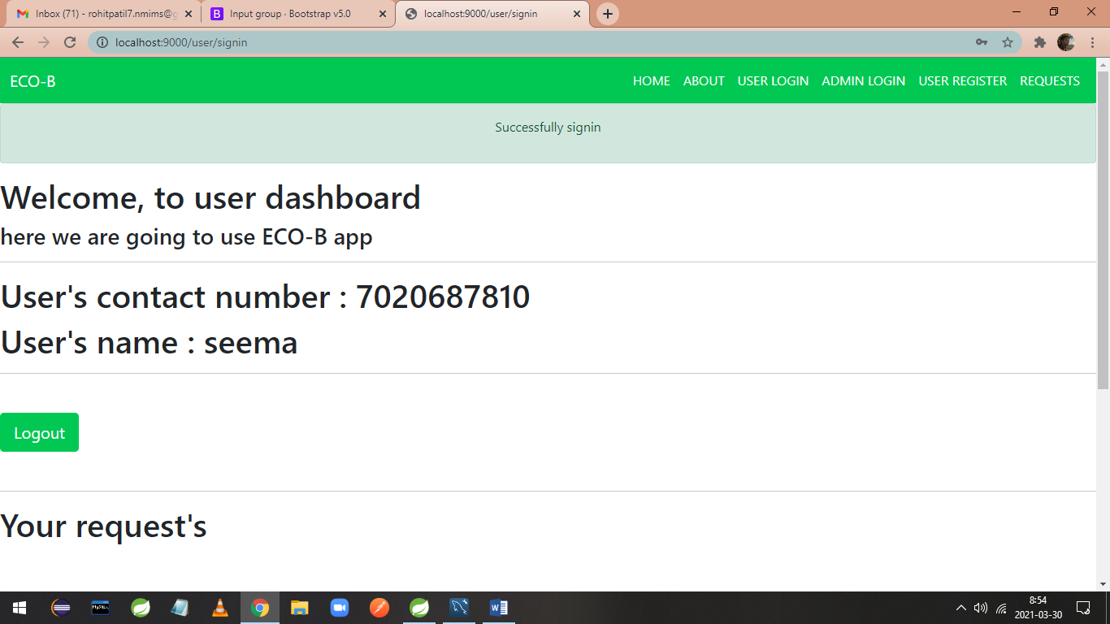

1. After scrolling user can see his approved and bicycle assigned request’s with bicycle id.

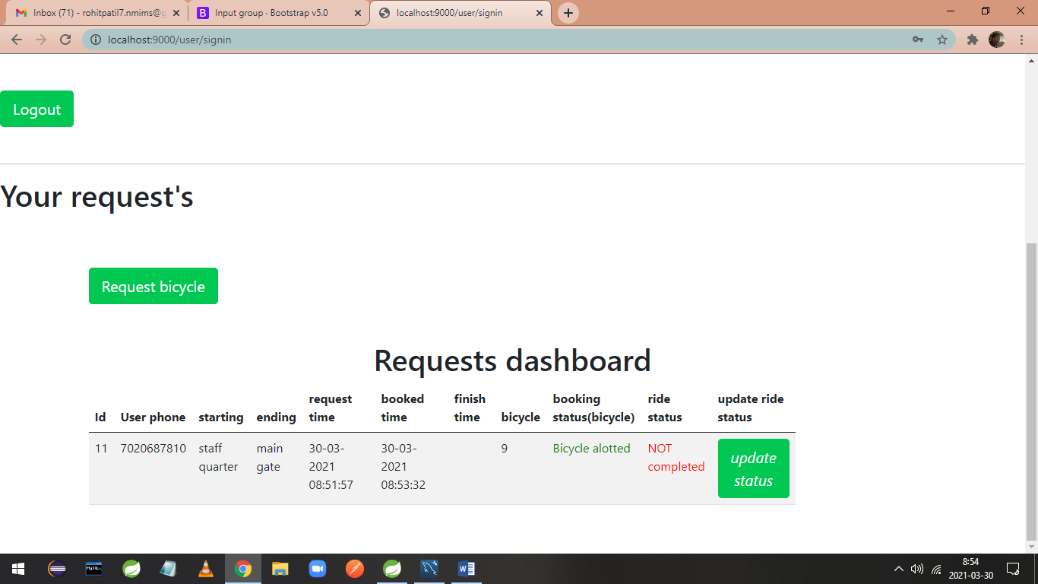

1. After clicking on update status user is directed to a form where he can give his ride finishing status.

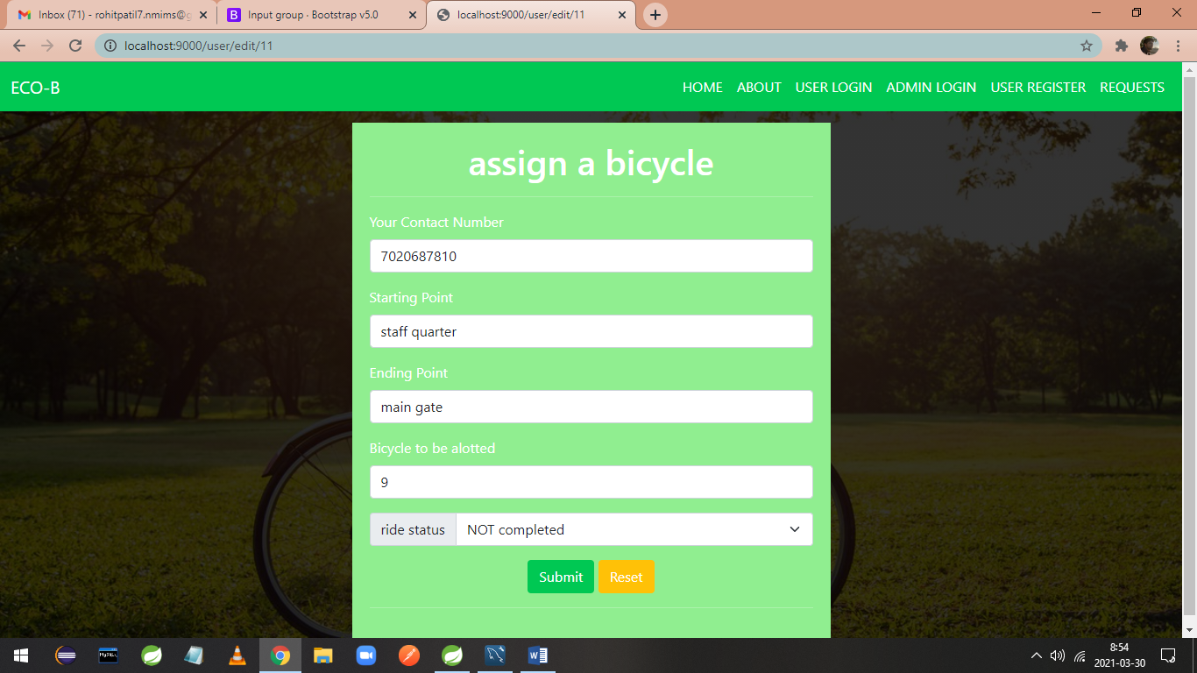

1. Completed option is selected.

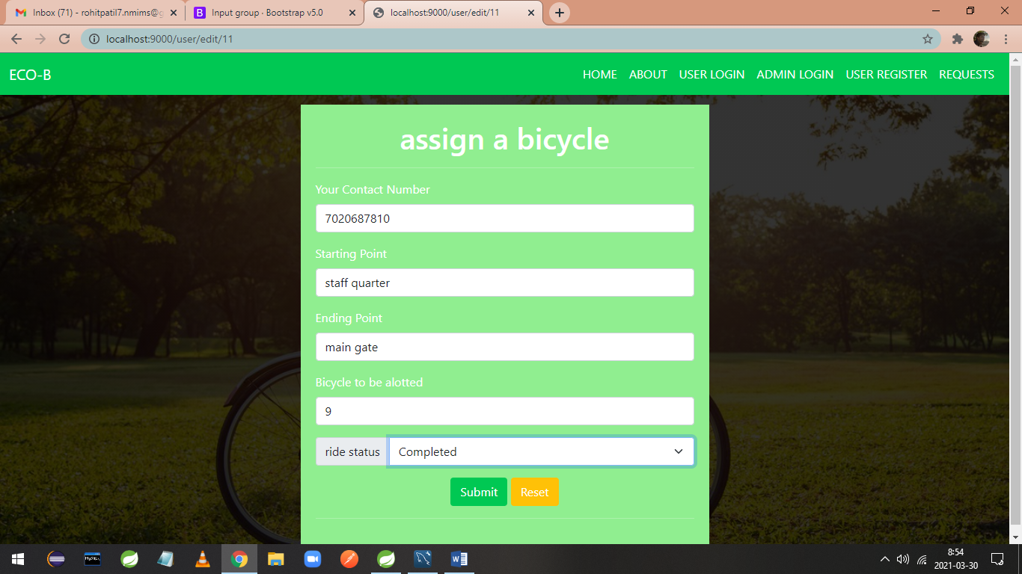

1. Ride status is updated as completed, with updated finish time. Now user can logout.

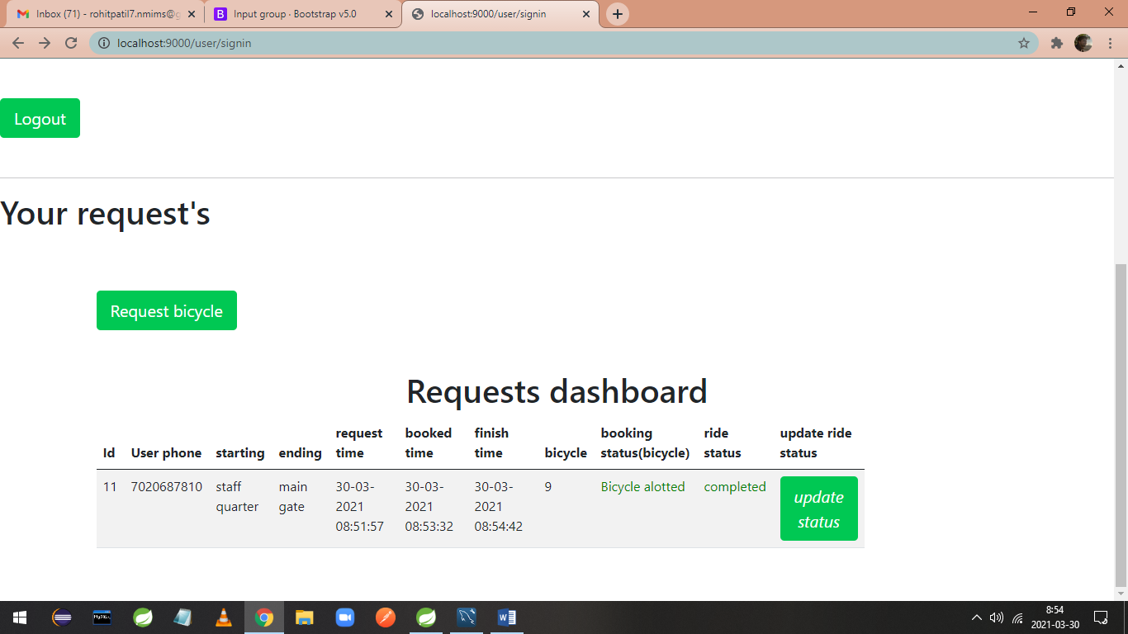

## 

# Table Structure

## users:

|  |  |  |  |  |  |
| --- | --- | --- | --- | --- | --- |
| Field | Type | Null | Key | Default | Extra |
| Contact_number | varchar(20) | NO | PRI | NULL |  |
| name | varchar2(50) | NO |  | NULL |  |
| password | varchar2(25) | NO |  | NULL |  |

## 

## admins:

|  |  |  |  |  |  |
| --- | --- | --- | --- | --- | --- |
| Field | Type | Null | Key | Default | Extra |
| Contact_number | varchar(20) | NO | PRI | NULL |  |
| name | varchar2(50) | YES |  | NULL |  |
| password | varchar2(25) | NO |  | NULL |  |

## bicycles:

|  |  |  |  |  |  |
| --- | --- | --- | --- | --- | --- |
| Field | Type | Null | Key | Default | Extra |
| bicycle_id | int | NO | PRI | NULL |  |
| bicycle_status | bit(1) | NO |  | NULL |  |
| bicycle_location_location_id | int | YES | MUL | NULL |  |
| location_location_id | int | YES | MUL | NULL |  |

## locations:

|  |  |  |  |  |  |
| --- | --- | --- | --- | --- | --- |
| Field | Type | Null | Key | Default | Extra |
| location_id | int | NO | PRI | NULL |  |
| location_name | varchar(20) | YES |  | NULL |  |

## requests:

|  |  |  |  |  |  |
| --- | --- | --- | --- | --- | --- |
| Field | Type | Null | Key | Default | Extra |
| request_id | int | NO | PRI | NULL | Auto_increment |
| bicycle_alotted | int | YES |  | NULL |  |
| booked_time | datetime | YES |  | NULL |  |
| ending_point | varchar(30) | NO |  | NULL |  |
| finish_time | datetime | YES |  | NULL |  |
| request_status | bit(1) | NO |  | NULL |  |
| request_time | datetime | YES |  | NULL |  |
| ride_status | bit(1) | NO |  | NULL |  |
| starting_point | varchar(30) | NO |  | NULL |  |
| user_id | int | NO |  | NULL |  |

1. **Conclusion**

Eco-B Point system is develop for book the bicycle ride. Book ride, report broken bicycle, add bicycles, remove bicycles, accept the user bicycle request and admin confirm the request, etc. similar to a society are the key features of our project. User can access services and functionalities from this application.

# Future Scope

The software is flexible enough to be modified and implemented as per future requirements. We have tried our best to present this user–friendly website to college members. Message and Email facilities are developed after booking ride send the message and email to the user from admin.

# References

1. <https://getbootstrap.com/>
2. <https://docs.oracle.com/javase/8/docs/api/>
3. <https://www.baeldung.com/java-streams/>
4. <https://www.baeldung.com/spring-mvc/>
5. <https://www.thymeleaf.org/apidocs/thymeleaf/3.0.12.RELEASE/>